# ***RAPTOR PROGRAMS***

M.POOJITHA ,192224094.

**TOTAL QUESTIONS**

**Q-EVEN OR ODD**

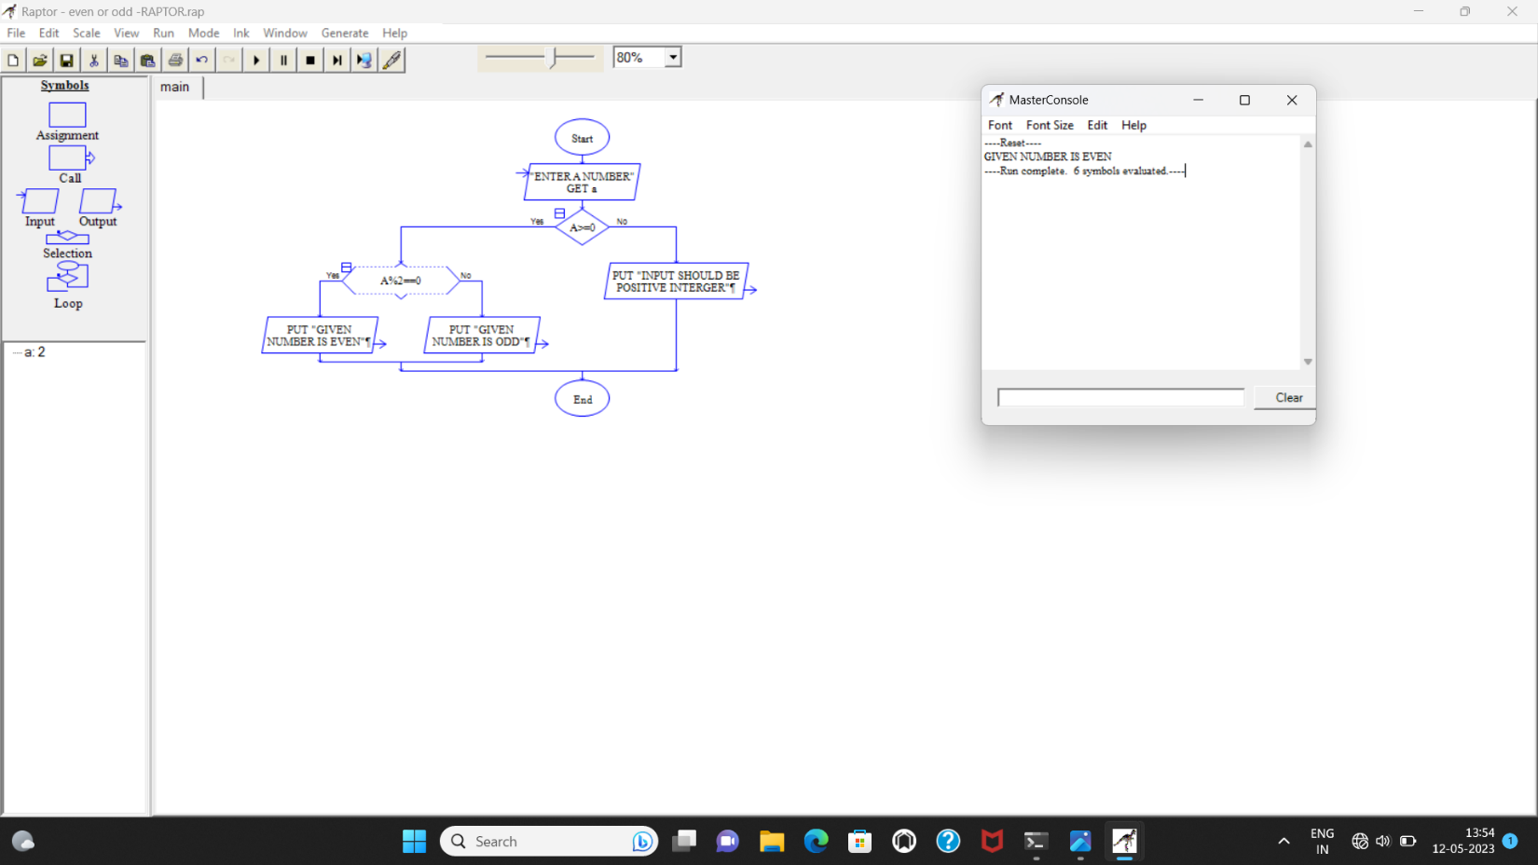

**Q-SUM OF INTEGERS**

